Research 3 Trading Desktop Apps:
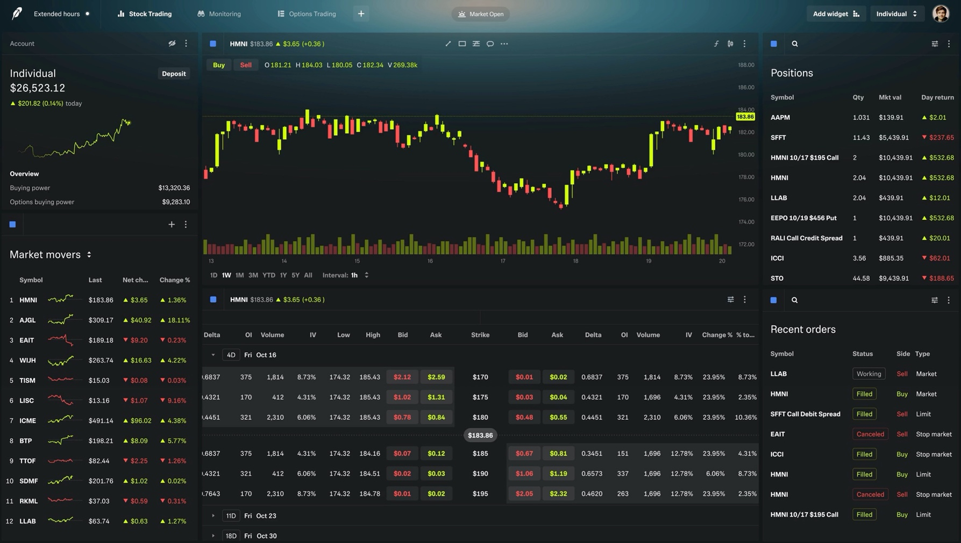
Robinhood (only found dark mode):

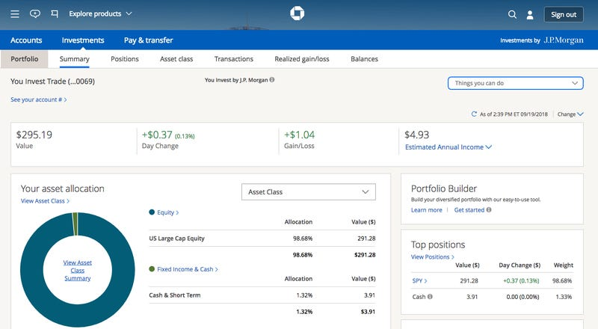
JP Morgan (only found light mode):

Fidelity:
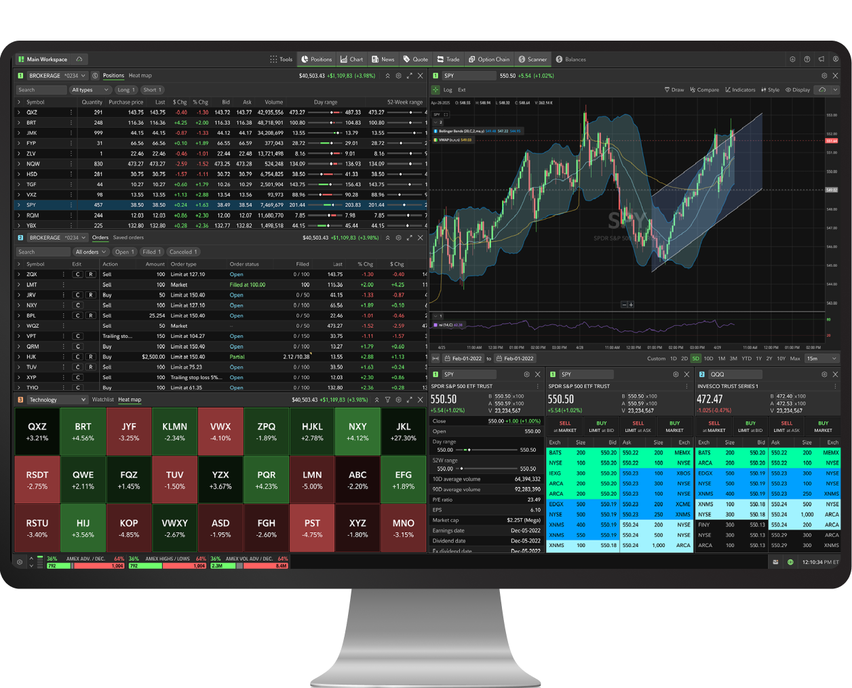
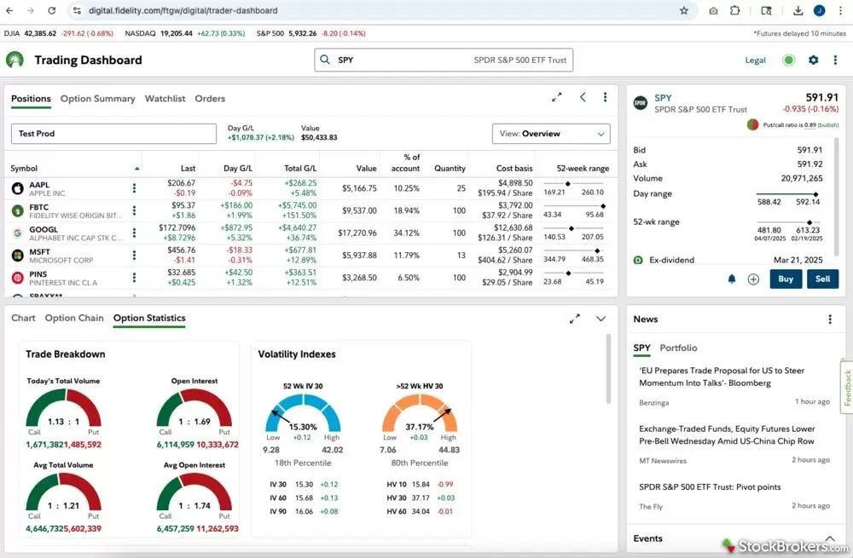

Similarities:
- The light modes between JP Morgan and Fidelity both seem more spaced out than all dark modes.
- Dense, low font pt. size, graph and number heavy/busy. To help quickly decipher price movement, color Is used (red for down, green for up) for distinguishing (both in the number text and in Fidelity they use color to make the heat map for tech stocks).
- Density of grids also separated by block panels – although some apps differ in how the panels are organized (4 columns, 2 columns, 3 columns — some panels span 1-2 columns).
- I’d assume all three have both light and dark modes.
- They all use line graphs to represent price change over time.
- All have sections somewhere for portfolio, navigation, account balances, transactions, positions, price data over time/graphs, trade execution, news, market overview. Portfolio at top.
- Colors: red for decrease in price movement, green for increase. Blue seems to be a neutral color for various tasks/indicators, yellow for volatility or event indicator.
Differences:
- JP morgan has a lot more space between information even within a panel relative to the other two apps.
- Overall layout of Robinhood seems much cleaner and aligned than Fidelity which appears denser and more complex.
- Buttons /navigation options are somewhat scattered in Fidelity but are at the top and efficiently placed in Robinhood.
- Unlike the other apps, JP Morgan has less in the landing page view and more on separate pages/tabs.

